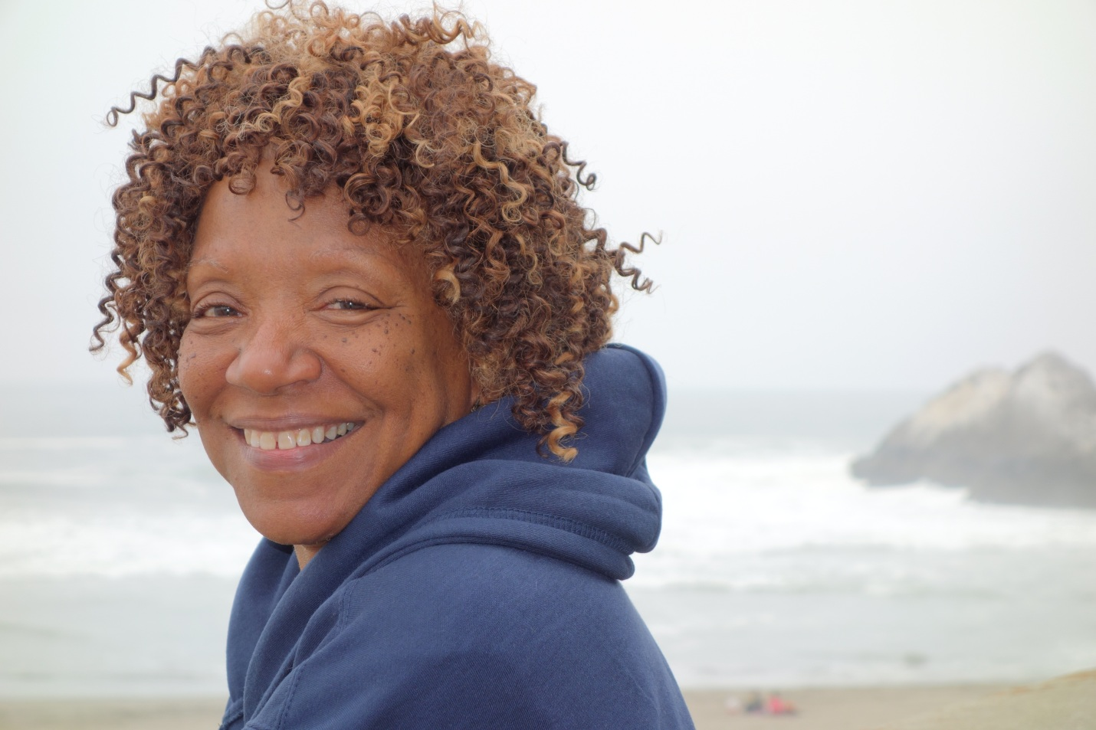
Photo credit: Tony Ryan

Cuban Poet Nancy Morejon in Richmond!

Sunday, April 10, 2016 - 3:00 pm- 5:00 pm

Madeline F. Whittlesey Community Room/ Richmond Main Library
325 Civic Plaza, near Macdonald Avenue

Nancy Morejon, a major Cuban poet, editor, essayist and critic, will be reading her poetry in Richmond April 10th. A member of the Editorial Board of Casa de las Americas journal, and Director of the Union of Artists and Writers of Cuba (UNEAC), Morejon’s work has been translated into many languages worldwide.

This FREE program will also include: translator/poet Kathleen Weaver; Richmond Co-Poet Laureate, Lincoln Bergman; and musicians Carolyn Brandy, Elizabeth Sayre and Amikaeyla playing music from Afrocuban traditions.

Please join us for an afternoon of poetry and music dedicated to US/Cuba friendship and the amazing Nancy Morejon! For more info please call (510) 860-3516 or email tonybook@att.net) Sponsored by the Richmond-Regla Cuba Friendship Committee, Richmond Arts & Culture Commission, the Bay Area Friends of Nancy Morejon, and The Turquino Project.

